NUDE YOGA and TANTRA MASSAGE retreat in SINGAPORE, CHANGI 1-2-3-4-MARCH 2019
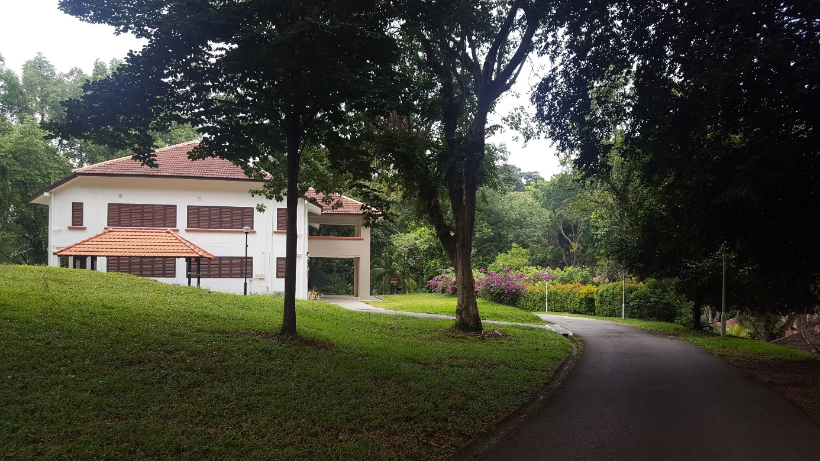
Four days of wonder and relaxing and new erotic experiences, together with 15 men. Close at the sea and beaches and near the Airport we stay at a wonderful chalet. We start every day with meditation and nude yoga to get prepared and embodied for the different kinds of massage: 5 Element massage, Cashmere Tantra massage, Chi Nei Tsang (belly organ) and Karsai Nei Tsang (genital massage), Pelvic floor release massage including prostate. We will also practice orgasmic yoga and orgasmic meditation to learn how to manage and circulate the sexual energy through your whole body. To become multi orgasmic. Instead of using porn focusing on body sensations and feeling more joy during self-pleasure. In a safe environment we learn from each other under the guidance of 2 experienced yoga and massage teachers.

Data: 1-2-3-4 March
Venue: Changi, Singapore
adres …….
Check in: 3pm on the 1st
Check out: 10.30 am ont the 4th
Costs: 560 sgd including lodging, BBQ on first evening,
3x breakfast, all classes and workshops.
Not included: all traveling costs, lunch and 2
evening dinners. (restaurants nearby)

